**User tutorial**

1. **Introduction to the homepage of the GutUDB.**

Upon opening the GutUDB database webpage, users can see the homepage as illustrated on the left side of the accompanying figure. The website does not require registration or login to use. Users can enter gene names in designated areas in the figure to directly search and analyze. At the same time, there are also navigation boxes and category pages for users to choose from.

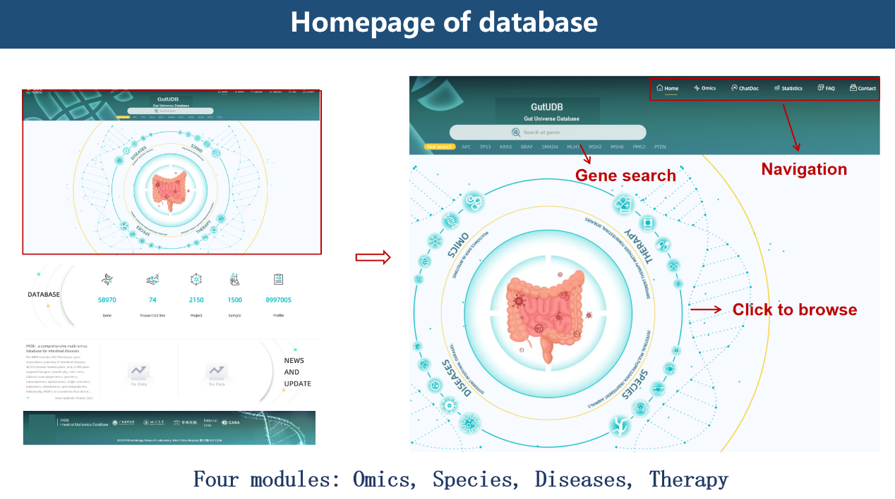

1. **Gene overall situation analysis and examples of the four major modules OMICS, SPECIES, DISEASES, and THERAPY are provided as follows.**

**(一) An example of gene overall situation analysis.**

1、Enter the gene name METTL3 in the search box marked by the red box in the picture below, and click search to analyze the overall situation of the gene.

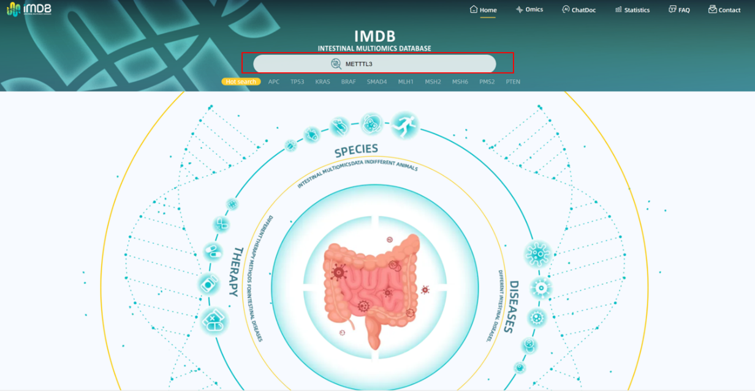

2、After searching for METTL3, users can also browse gene details, gene-related maps, omics information, drug information, gene expression levels in different tissues and differential analysis. Click "profile" to view the expression levels of the gene in different tissues and the expression differences in different intestinal diseases.

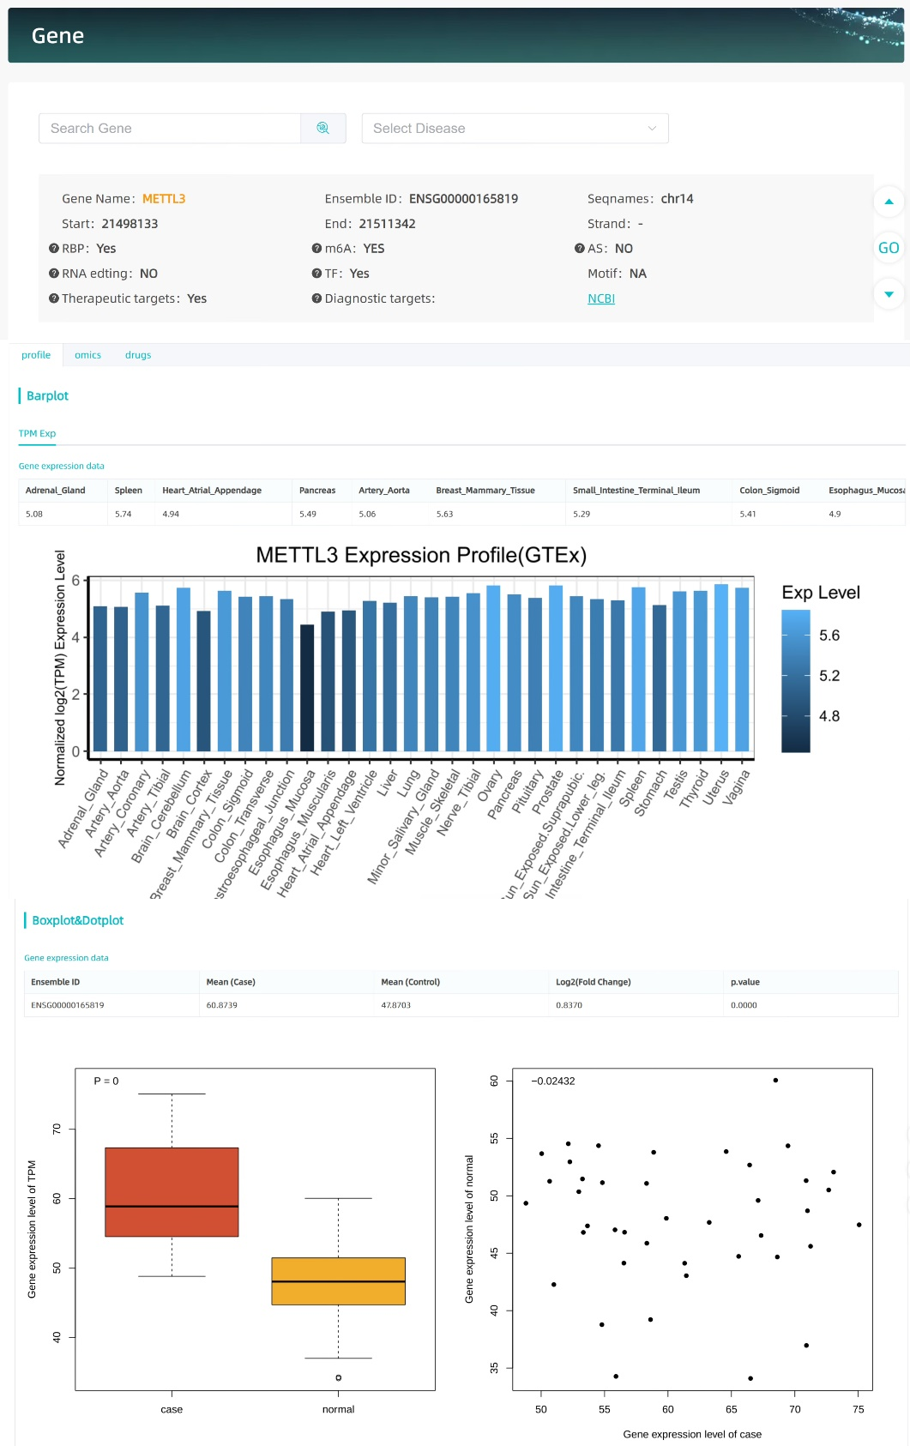

3、Users can also continue to click “omics” to view the unique related information of the gene in different omics data, as shown below.

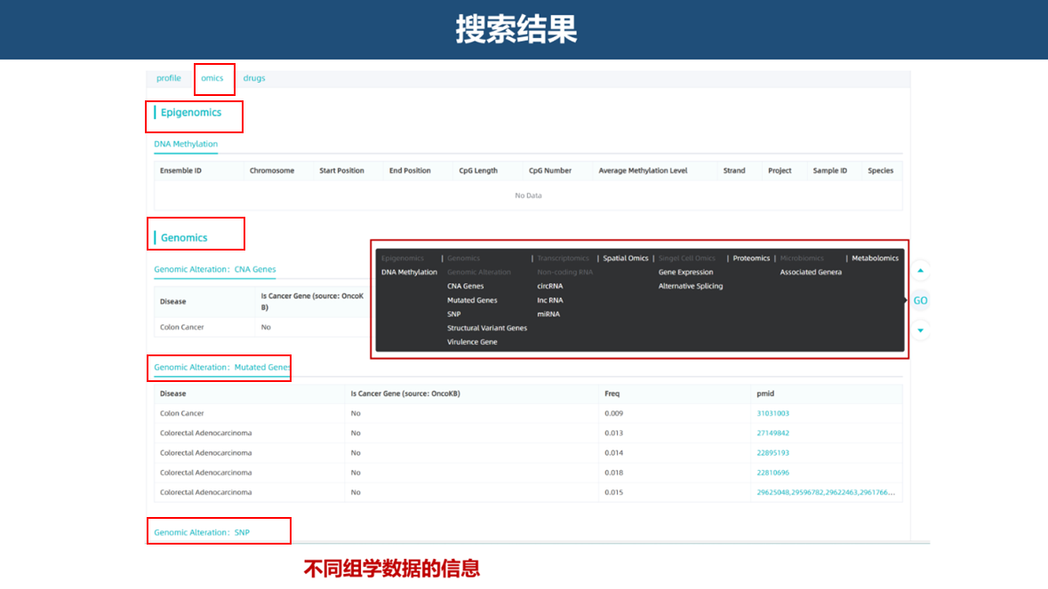

4、Users can click "drugs" to view the therapeutic drugs related to the gene and intestinal diseases, including chemical compounds, traditional medicine, or probiotics. If the page displays "No Data", it means that there are currently no relevant research reports, as shown in the figure below.

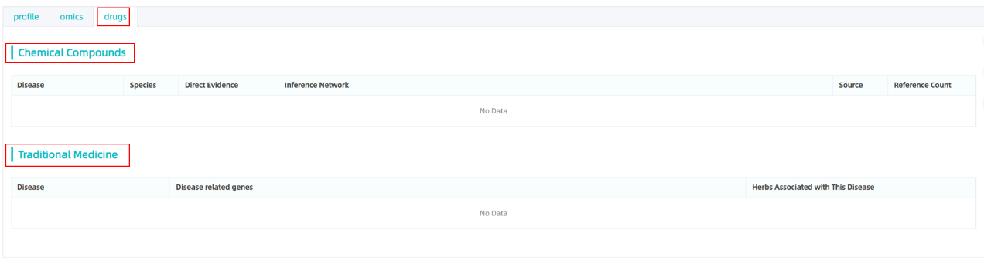

**(二) Examples of the DISEASE module.**

1、Users can click " DISEASE " to browse the module.

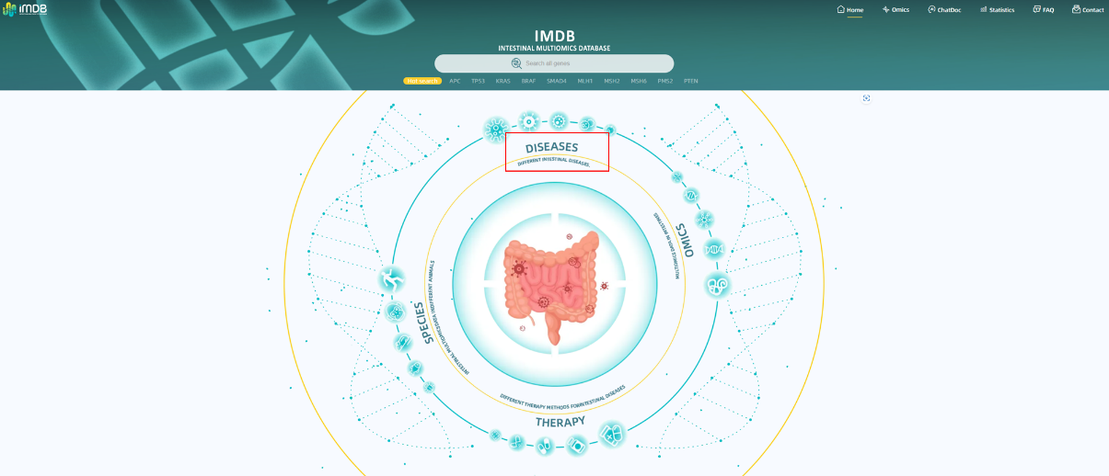

2、Users can enter the gene name TP53 in the search box to view the correlation information of TP53 in different intestinal diseases and omics, as shown in the figure below.

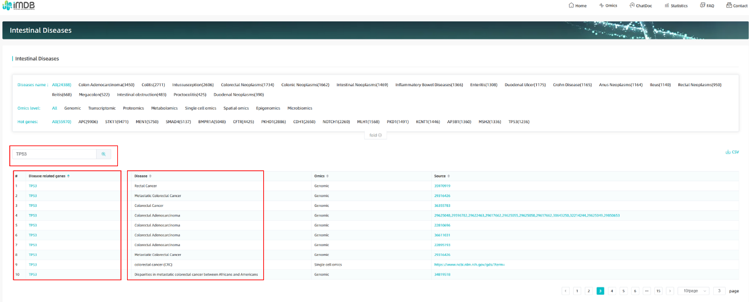

3、Users can click on the gene name in the previous column of various diseases to view the detailed information of the gene, as shown in the figure below.

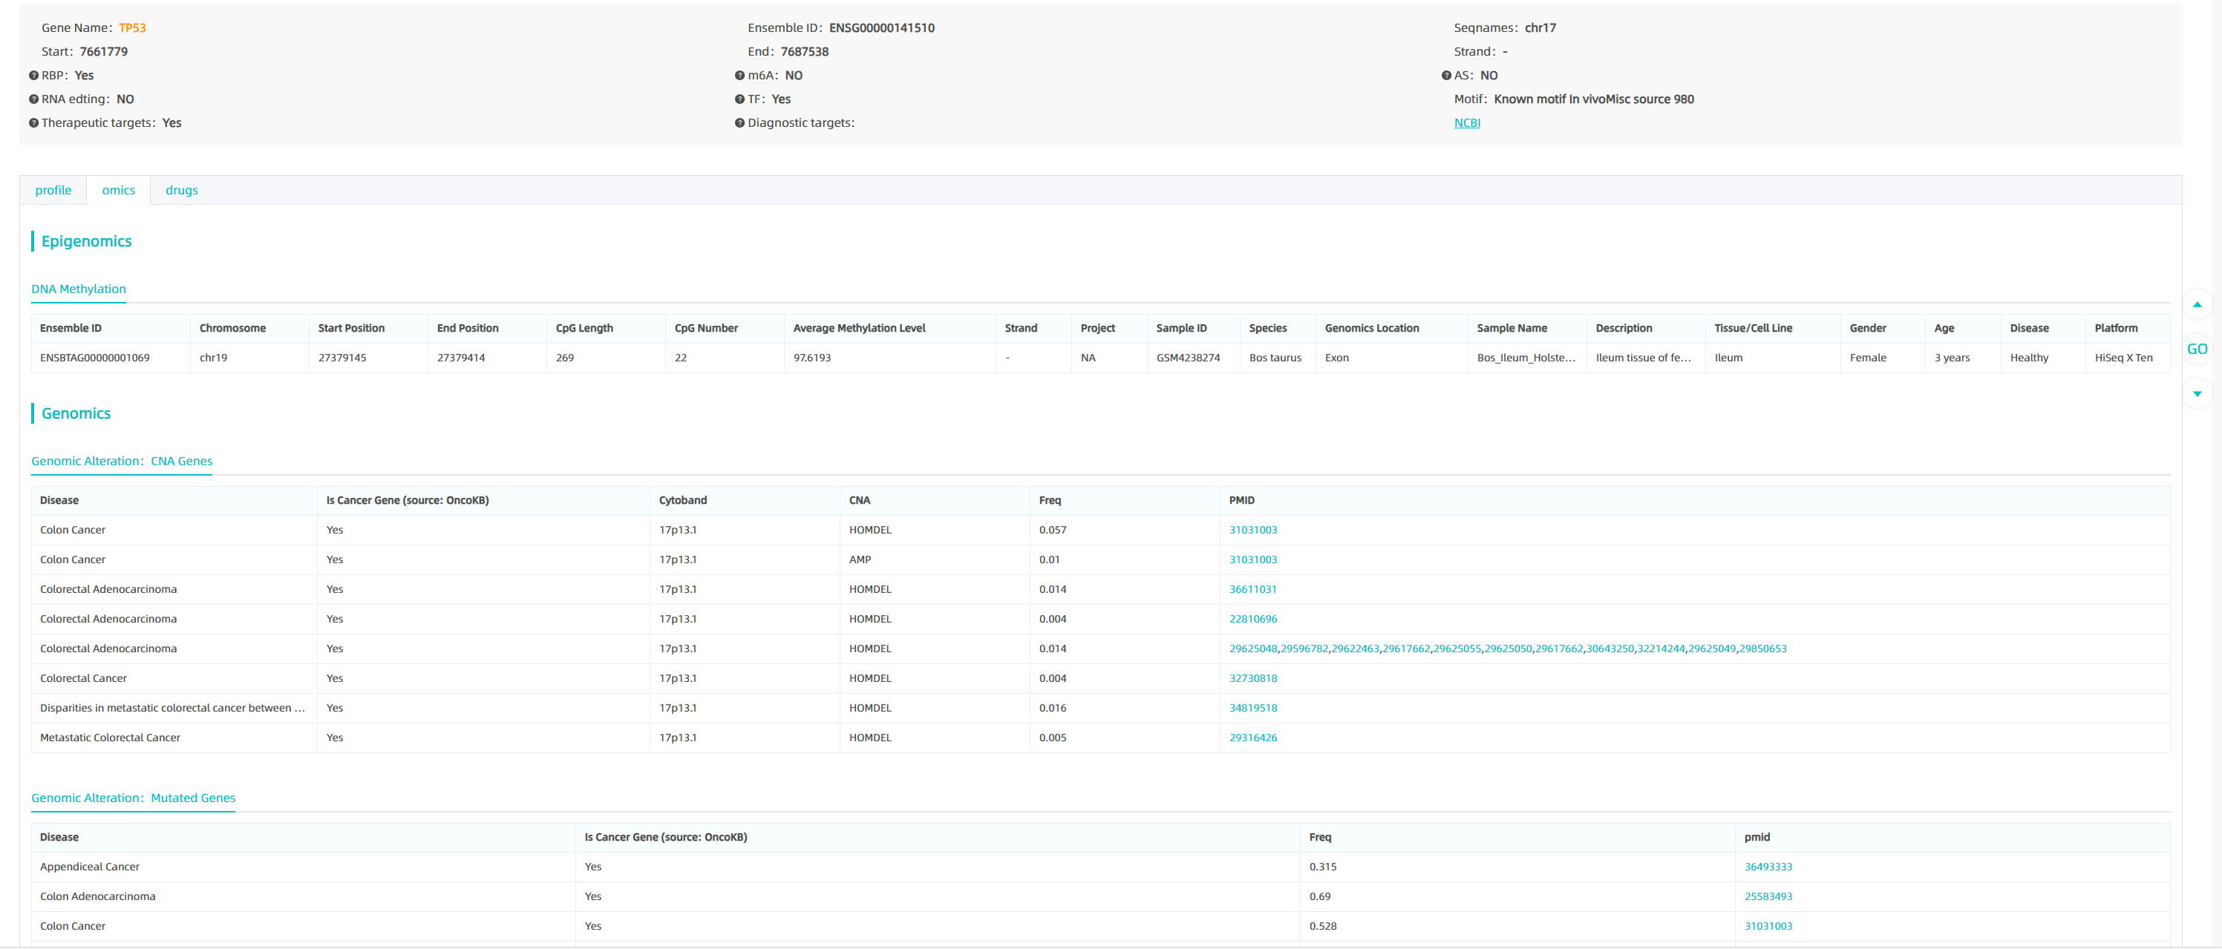

4、Users can also select intestinal diseases and omics data information of interest, as well as hot genes to view.

**(三) Examples of the Therapy module.**

1、Users can click " THERAPY " to browse the module.

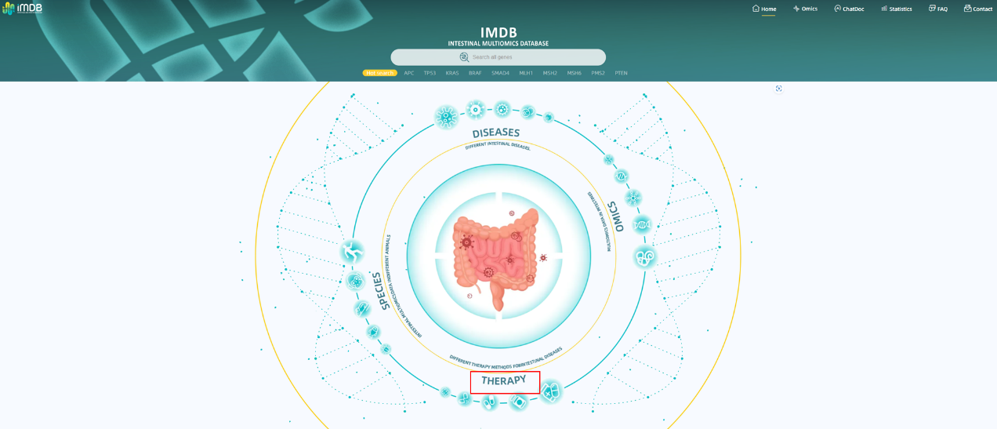

2、Users can select one or more of chemical compounds, traditional medicine, or probiotics to view.

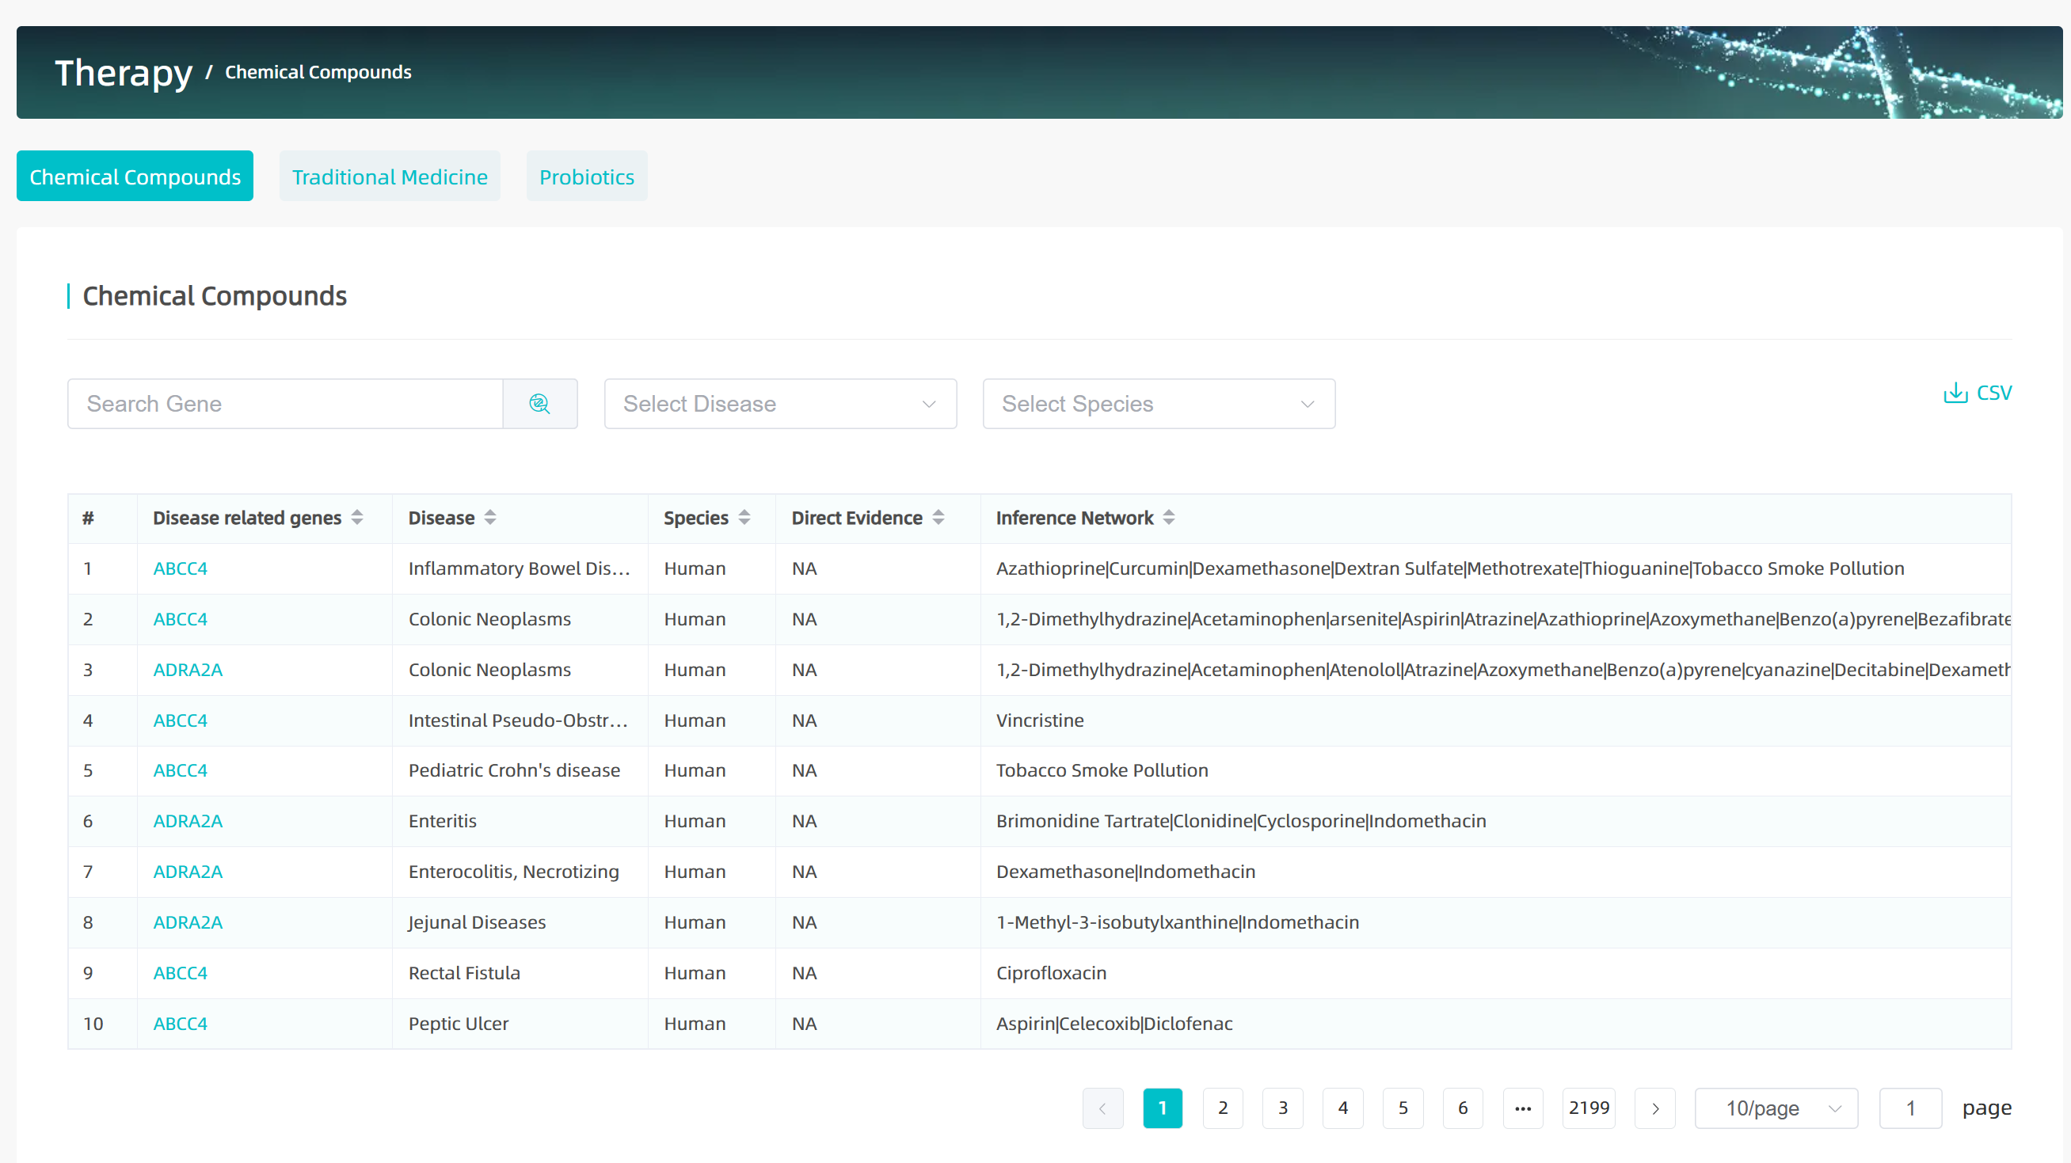

3、Users can enter the gene name TP53 in the search box to view the therapeutic drugs associated with this gene in different intestinal diseases. These drugs include various types such as chemical compounds, traditional medicine, or probiotics. As well as treatments in different species of this gene, relevant literature has been added, as shown in the figure below.

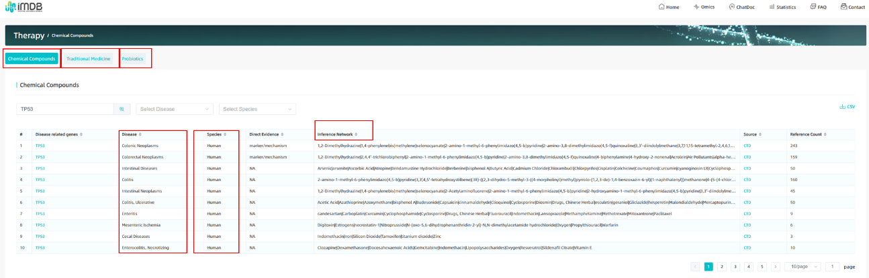

**(四) Examples of the SPECIES module.**

1、Users can click " SPECIES " to browse the module.

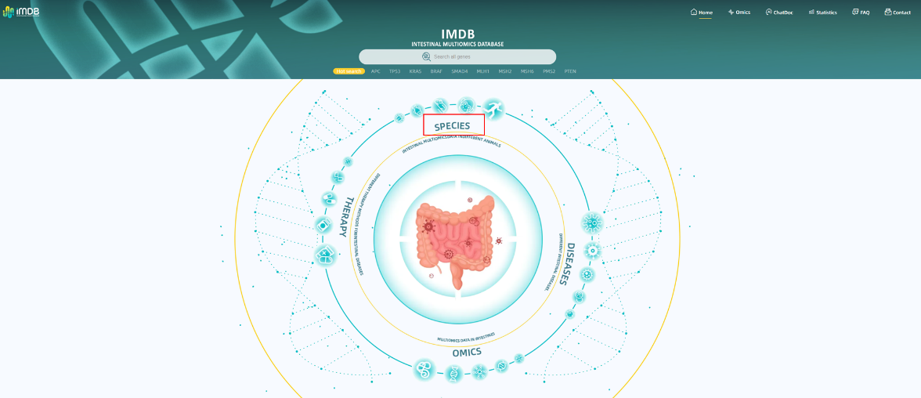

2、Users can enter the gene name TP53 in the search box to browse the status of TP53 in different species. We have collected relevant research on various species including humans, mice, primates, etc. You can also view information on different diseases. At the same time, relevant research documents can be traced, as shown in the figure below.

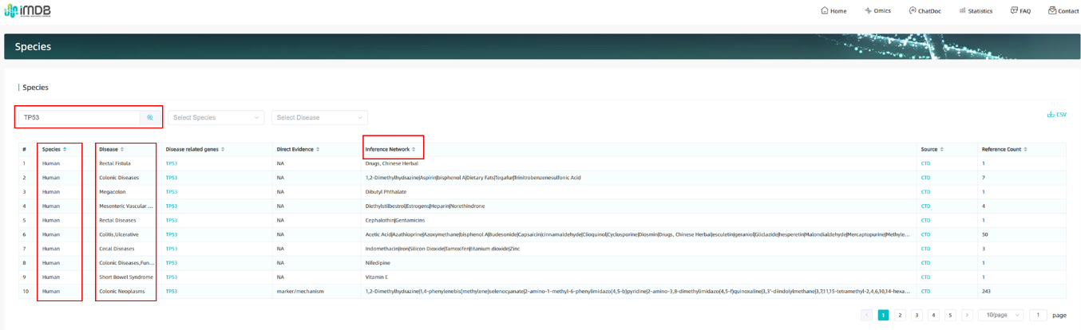

**(五) Examples of the OMICS module.**

1、Users can click "OMICS" to browse the module.

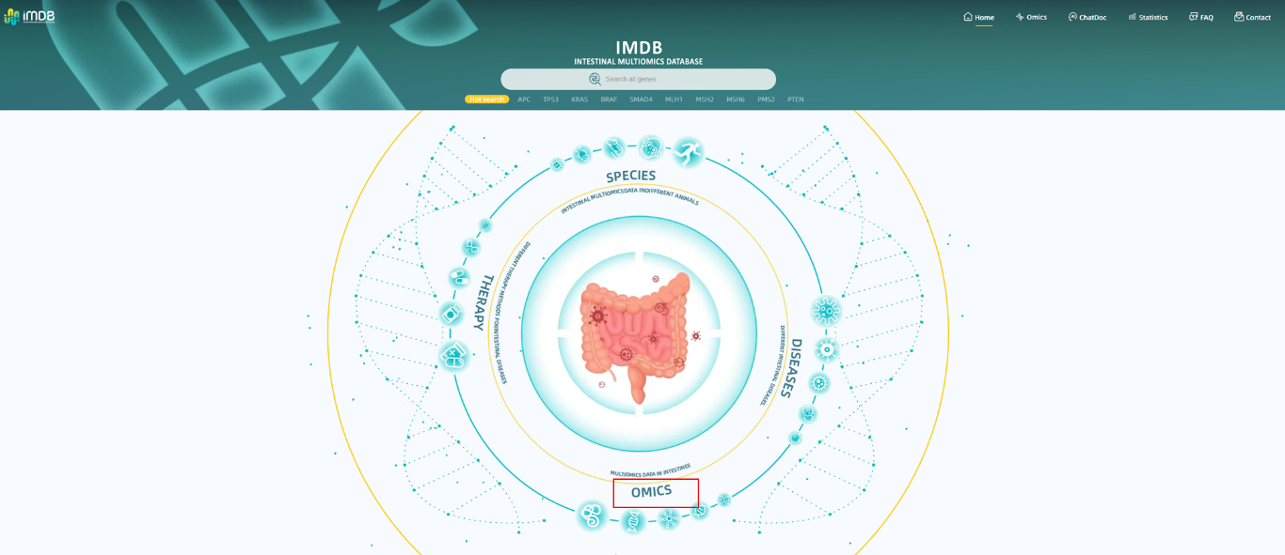

2、The OMICS module contains a variety of omics information: including genomics, epigenomics, single-cell omics, transcriptomics, proteomics, spatial omics, etc.

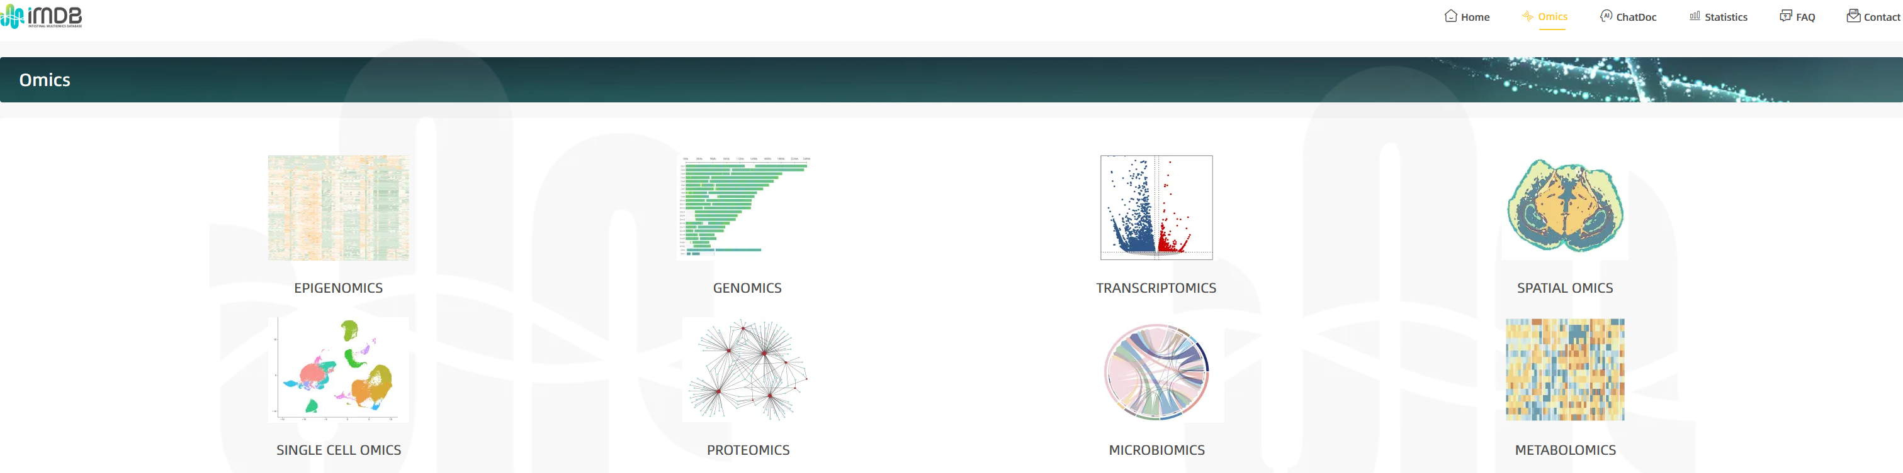

3、In the epigenomics section, search for the gene of interest such as TP53, and you can view various information of the gene's Epigenomics, such as DNA Methylation, Histone Modification and Chromosome Structure, etc. Click the download button to get the relevant analysis result charts.

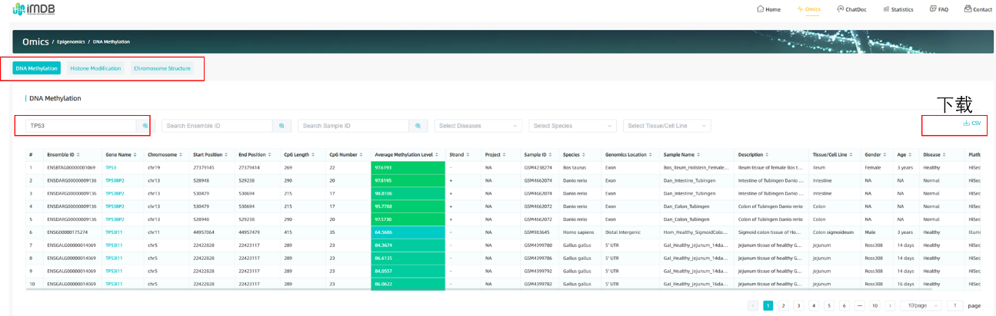

4、Open single-cell omics, you can search for the gene of interest and view various information of the single-cell omics of the gene, such as Gene expression, Alternative Polvadenylation, Alternative Splicing and Proteomics, etc. Click the download button to get the relevant analysis result charts.

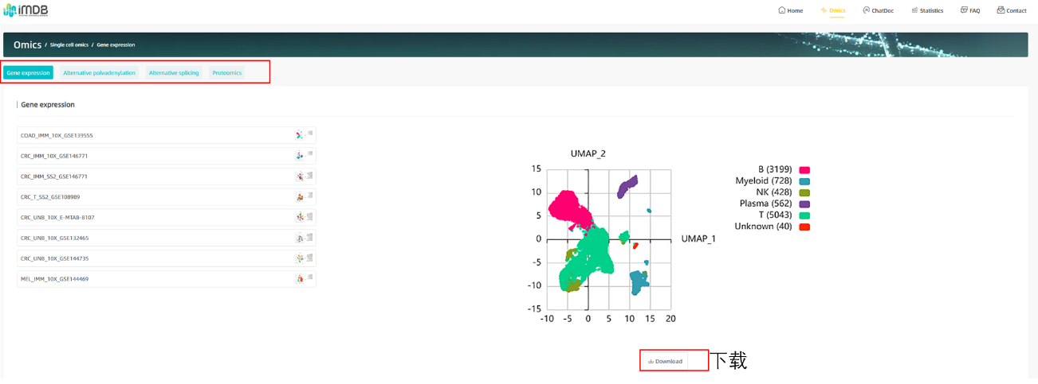

5、In the Proteomics section, you can search for gene of interest, view the proteomic information of this gene in different diseases and species, and trace relevant literature. Click the download button to get the relevant analysis result charts.

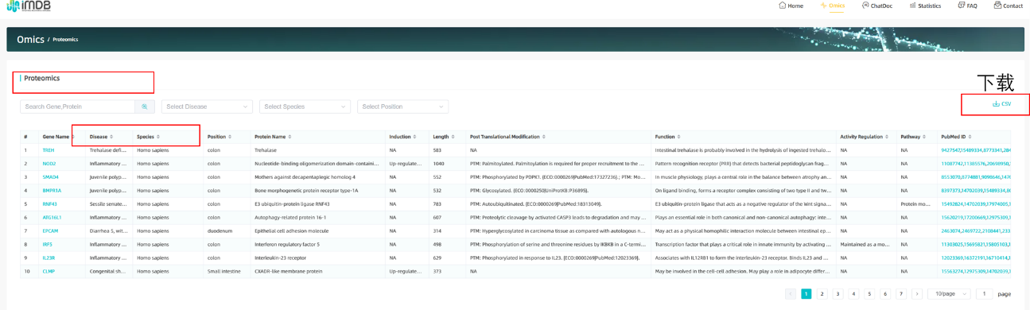

6、By accessing the genomics section, you can search for gene of interest, view the genomic information of the gene in different diseases, including Genomic Alteration and Virulence Gene, and trace relevant literature. Click the download button to get the relevant analysis result charts.

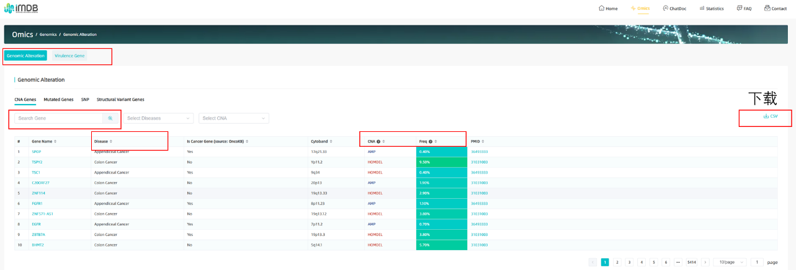

7、Information search for transcriptomics, spatial omics, metabolomics, and microbiomics is also similar to the search and analysis of the above types of omics.